Student Application Project Deploy Using Docker
1.Create one instance.At instance Creation write script to install my sql,git,docker.get permission to docekr and download application through git clone
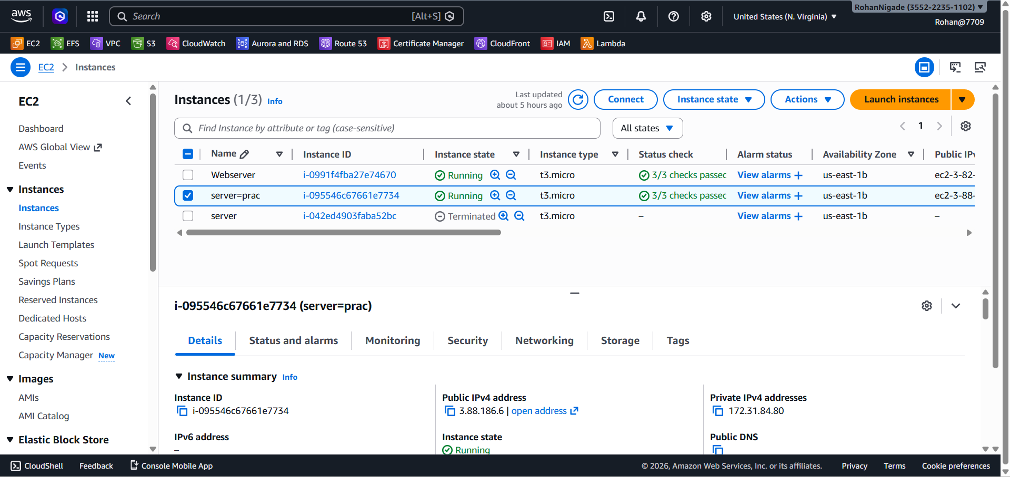
2.Create Database and connect to ec2 instace
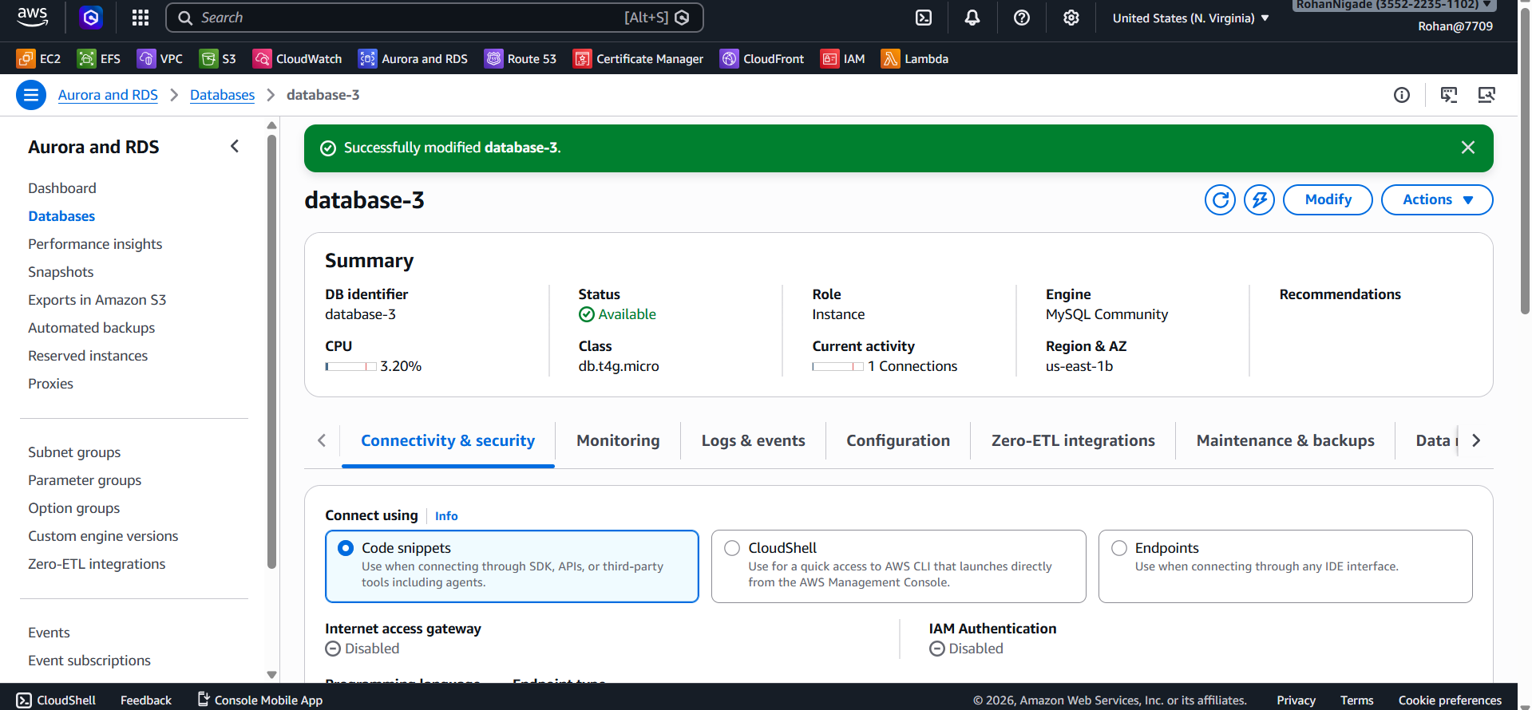
3.Connect to terminus by rds endpoint and create table in RDS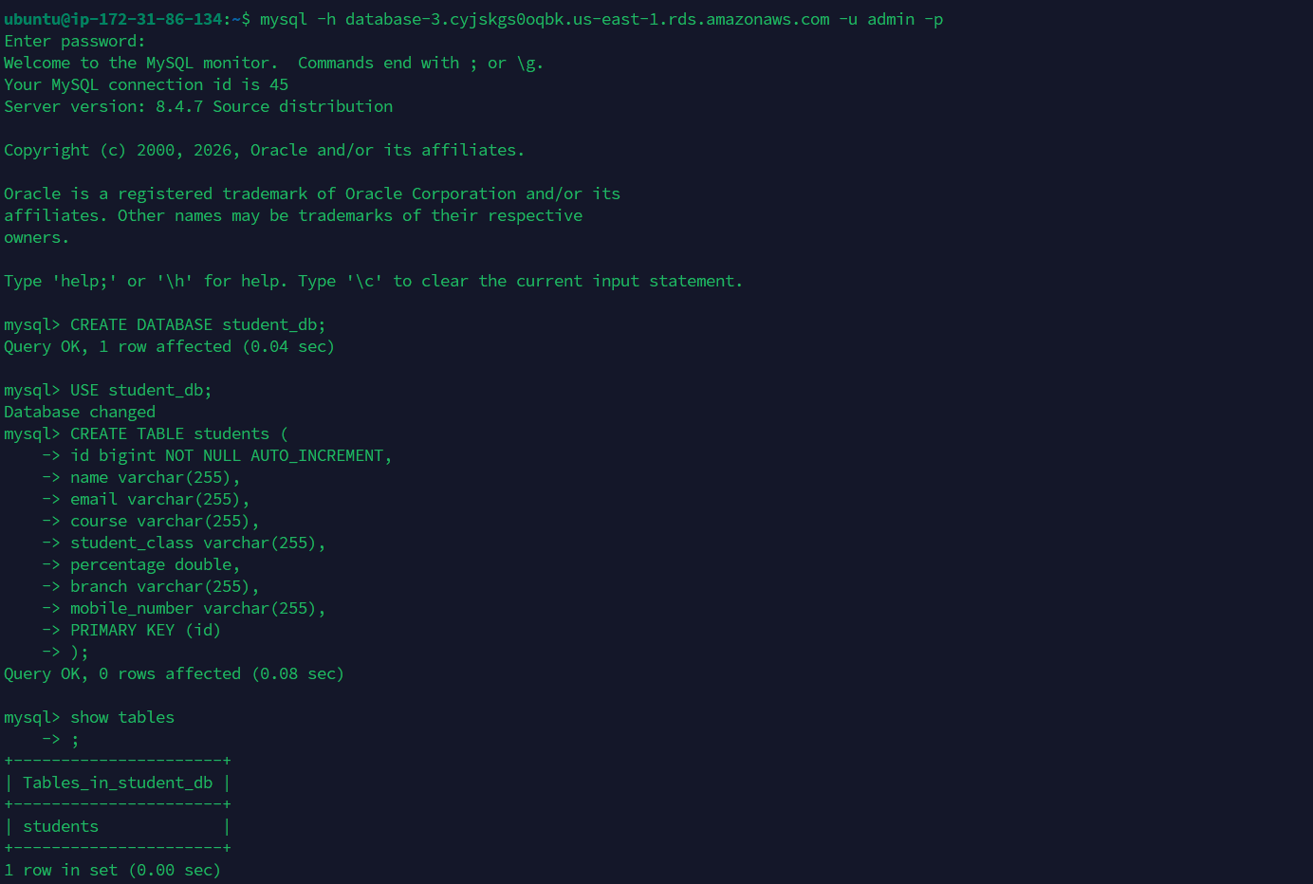
4.Download git application .Go to application.properties file and add RDS endpoint and username,password and save it
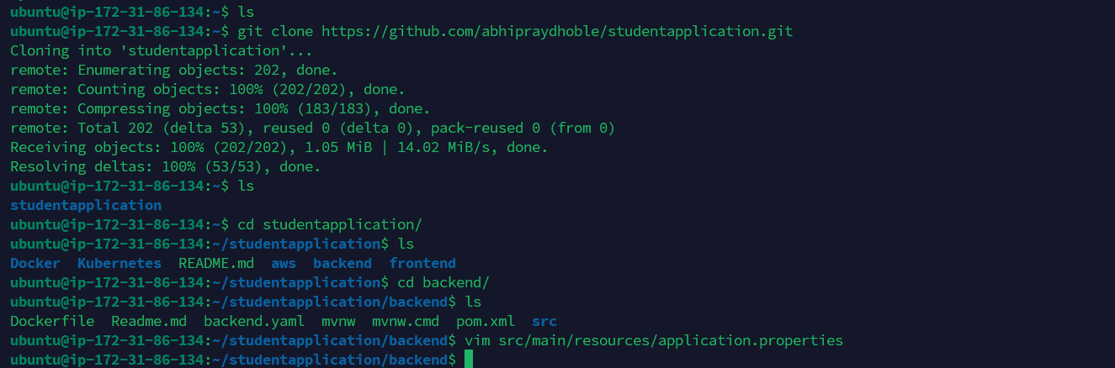
5.Create docker image by built –t command and contenerize it in docker container
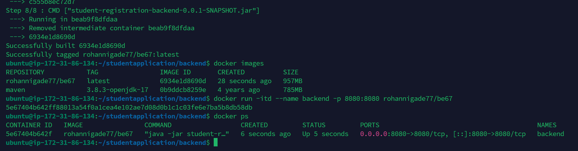

6.Go to folder frontend and in .env file add instane ip address and build image.
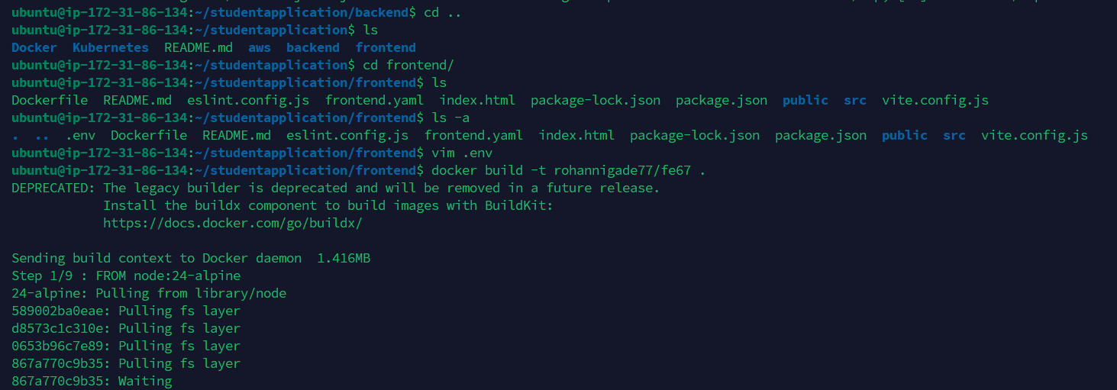

7.Image is built and create its container and run it
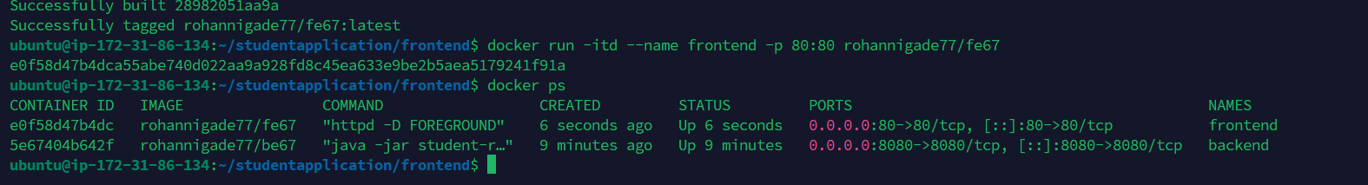
8.Copy the IP address of instance and check it. It successfully Run

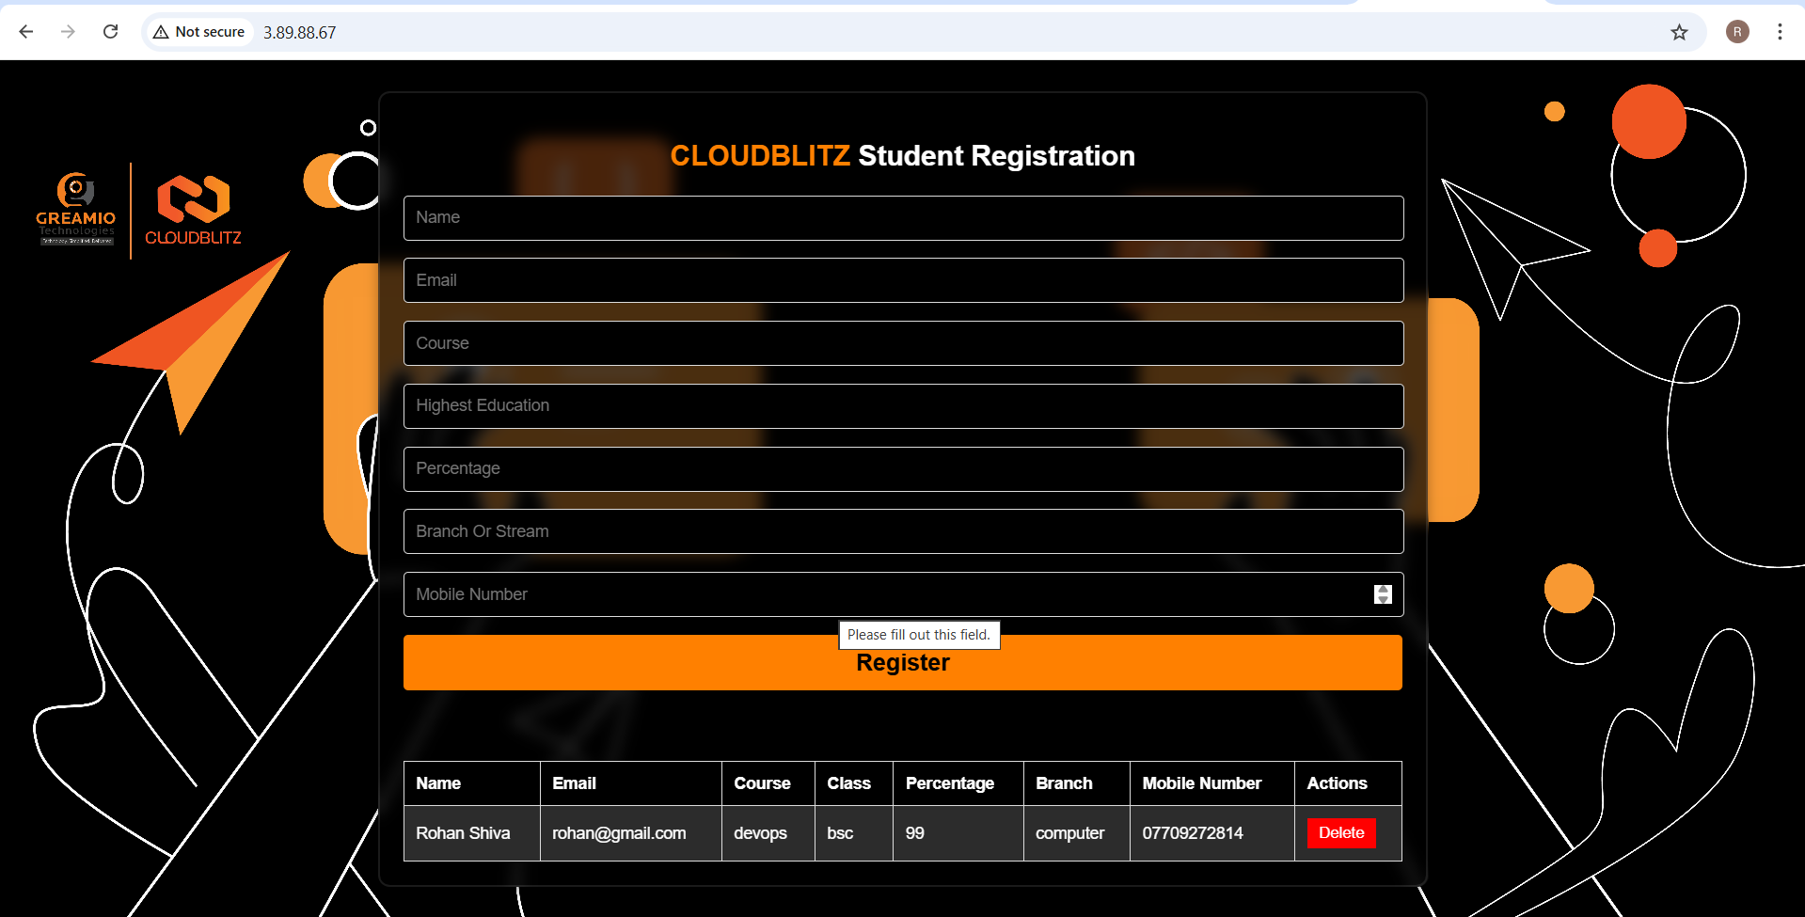

9.Data is saved in user table
